**Converting xml and json in c#**

1. Write a simple application that should allow you to open an XML file and visualize data using the DataGridView control. The application should be created as a window application for the Windows operating system.

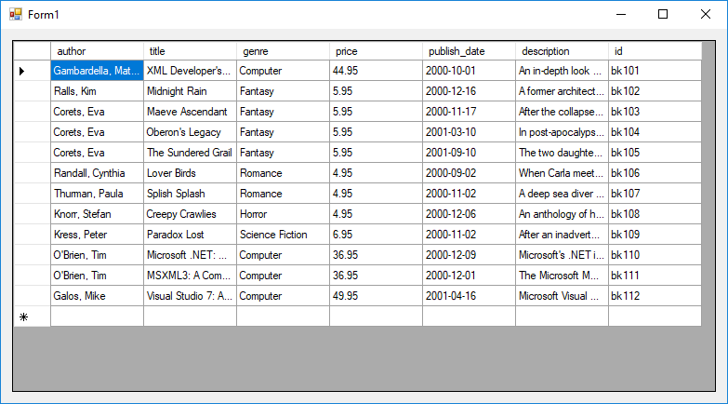

1. Write an application that will allow you to convert weather data from the data file All.txt (text separated by tabs) to JSON format. Converted data should be saved in the AllData.json l file

Output data in JSON viewer.

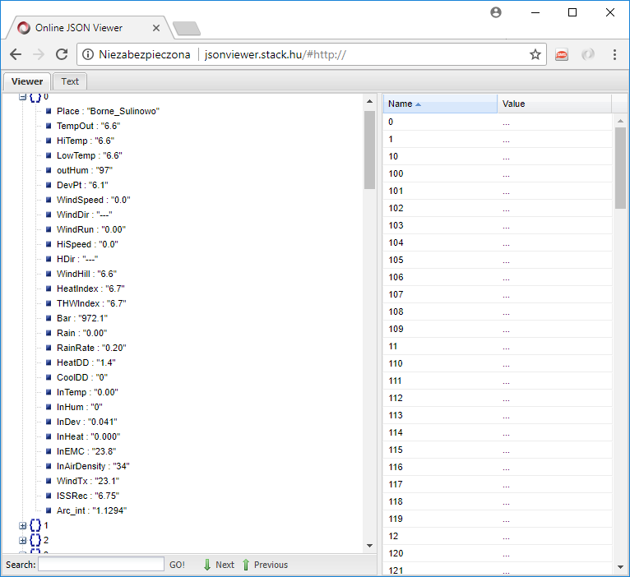

**Links and references**

Processing XML in c#

* <https://msdn.microsoft.com/en-us/library/ekw4dh3f.aspx>
* <http://www.doublecloud.org/2013/08/parsing-xml-in-c-a-quick-working-sample/>

Processing JSON in c#

* <https://www.newtonsoft.com/json/help/html/Introduction.htm>
* <https://www.codeproject.com/Tips/397574/Use-Csharp-to-get-JSON-Data-from-the-Web-and-Map-i>